**Project Design Phase-II**

**Technology Stack (Architecture & Stack)**

| Date | 27 October 2023 |
| --- | --- |
| Team ID | PNT2022TMIDxxxxxx |
| Project Name | Walmart sales analysis with machine learning |
| Maximum Marks | 4 Marks |

Architectural Diagram

Application Components and Technology Blocks:

* Web UI: The web UI is the user interface for the sales data visualization. It is implemented using HTML, CSS, and JavaScript.
* Data Ingestion: The data ingestion layer is responsible for ingesting and preprocessing the Walmart sales data. It is implemented using Python
* Data Analysis: The data analysis layer is responsible for performing sales data analysis. It is implemented using Python, Pandas, and NumPy.
* Machine Learning: The machine learning layer contains the machine learning models for sales prediction. It is implemented using Scikit-Learn and TensorFlow.

Infrastructure Demarcation:

* The web UI is deployed to a cloud-based web server, such as Azure App Service.
* The data ingestion, data analysis, and machine learning layers are deployed to a cloud-based container orchestration platform, such as Kubernetes.
* The database is deployed to a cloud-based database service, such as AWS RDS or Azure Cosmos DB.

External Interfaces:

* The data ingestion layer integrates with the Walmart API to ingest the sales data.
* The machine learning layer integrates with the OpenWeather API and Federal Reserve API to integrate weather data and economic indicators.

Data Storage Components/Services:

* The database layer stores the Walmart sales data, machine learning models, and other application data. It is implemented using PostgreSQL or NoSQL.
* The file storage layer stores the datasets and reports. It is implemented using AWS S3 or Azure Blob Storage.

Interface to Machine Learning Models:

* The machine learning layer exposes an API that can be used to access and make predictions from the machine learning models.

Technical Architecture for Walmart sales analysis with machine learning:

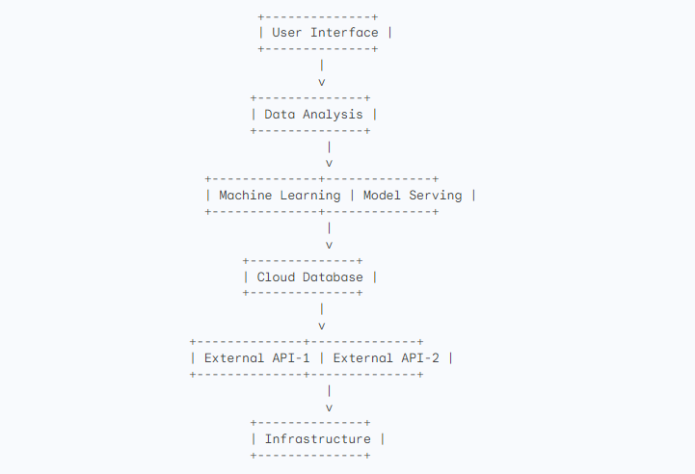

* User Interface: Provides a web UI for visualizing the sales data and insights. (Local)
* Data Analysis: Performs exploratory data analysis (EDA) and feature engineering on the ingested data. (Local)
* Machine Learning: Trains and deploys machine learning models to predict sales. (Local)
* Model Serving: Logic to serve the trained machine learning models to other components of the system. (Local)
* Cloud Database: Stores the sales data, weather data, and economic data. (Cloud)
* External API-1: Weather API (Cloud)
* External API-2: Economic Data API (Cloud)
* Infrastructure: Provides the underlying infrastructure for the application, including load balancing and monitoring. (Cloud)

**TABLE 1: Components & Technologies**

| S.No | Component | Description | Technology |
| --- | --- | --- | --- |
| 1 | User Interface | Web UI for sales data visualization | HTML, CSS, JavaScript |
| 2 | Data Ingestion | Logic for ingesting and preprocessing data | Python |
| 3 | Data Analysis | Logic for sales data analysis | Python, Pandas, NumPy |
| 4 | Machine Learning | Machine learning models for sales prediction | Scikit-Learn, TensorFlow |
| 7 | File Storage | File storage for datasets and reports | Azure Blob Storage |
| 10 | Infrastructure | Application Deployment | Azure |